26.66: For three identical resistors in series, 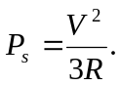 If they are now in parallel over the same voltage, 